DARLLENWCH Y DARN ISOD AC ATEBWCH Y CWESTIYNAU SY’N DILYN.
Bohr Atomic Model:
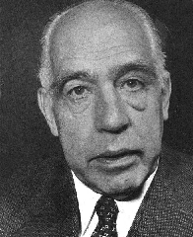
In 1913 Bohr proposed his quantized shell model of the atom to explain how electrons can have stable orbits around the nucleus. The motion of the electrons in the Rutherford model was unstable because, according to classical mechanics and electromagnetic theory, any charged particle moving on a curved path emits electromagnetic radiation; thus, the electrons would lose energy and spiral into the nucleus.
To remedy the stability problem, Bohr modified the Rutherford model by requiring that the electrons move in orbits of fixed size and energy. The energy of an electron depends on the size of the orbit and is lower for smaller orbits. Radiation can occur only when the electron jumps from one orbit to another. The atom will be completely stable in the state with the smallest orbit, since there is no orbit of lower energy into which the electron can jump.
Bohr's starting point was to realize that classical mechanics by itself could never explain the atom's stability. A stable atom has a certain size so that any equation describing it must contain some fundamental constant or combination of constants with a dimension of length. The classical fundamental constants--namely, the charges and the masses of the electron and the nucleus--cannot be combined to make a length. Bohr noticed, however, that the quantum constant formulated by the German physicist Max Planck has dimensions which, when combined with the mass and charge of the electron, produce a measure of length. Numerically, the measure is close to the known size of atoms. This encouraged Bohr to use Planck's constant in searching for a theory of the atom.
Planck had introduced his constant in 1900 in a formula explaining the light radiation emitted from heated bodies. According to classical theory, comparable amounts of light energy should be produced at all frequencies. This is not only contrary to observation but also implies the absurd result that the total energy radiated by a heated body should be infinite. Planck postulated that energy could only be emitted or absorbed in discrete amounts, which he called quanta (the Latin word for "how much"). The energy quantum is related to the frequency of the light by a new fundamental constant, h. When a body is heated, its radiant energy in a particular frequency range is, according to classical theory, proportional to the temperature of the body. With Planck's hypothesis, however, the radiation can occur only in quantum amounts of energy.
If the radiant energy is less than the quantum of energy, the amount of light in that frequency range will be reduced. Planck's formula correctly describes radiation from heated bodies. Planck's constant has the dimensions of action, which may be expressed as units of energy multiplied by time, units of momentum multiplied by length, or units of angular momentum. For example, Planck's constant can be written as h = 6.6x10⁻³⁴ joule seconds.

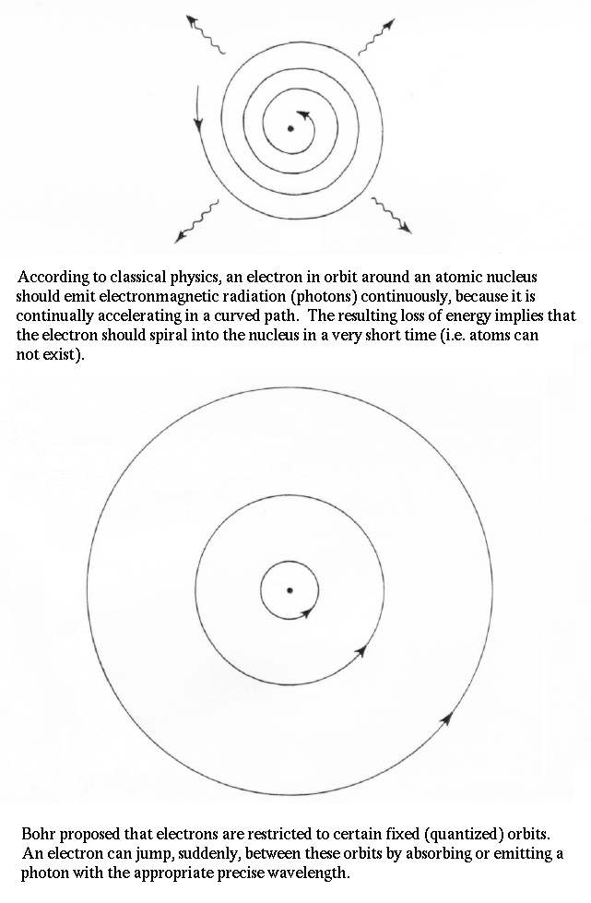

Using Planck's constant, Bohr obtained an accurate formula for the energy levels of the hydrogen atom. He postulated that the angular momentum of the electron is quantized--i.e. it can have only discrete values. He assumed that otherwise electrons obey the laws of classical mechanics by travelling around the nucleus in circular orbits. Because of the quantization, the electron orbits have fixed sizes and energies. The orbits are labelled by an integer, the quantum number n.
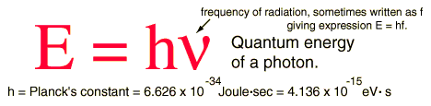

With his model, Bohr explained how electrons could jump from one orbit to another only by emitting or absorbing energy in fixed quanta. For example, if an electron jumps one orbit closer to the nucleus, it must emit energy equal to the difference of the energies of the two orbits. Conversely, when the electron jumps to a larger orbit, it must absorb a quantum of light equal in energy to the difference in orbits.
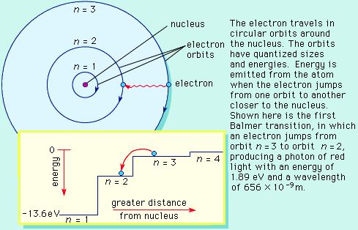
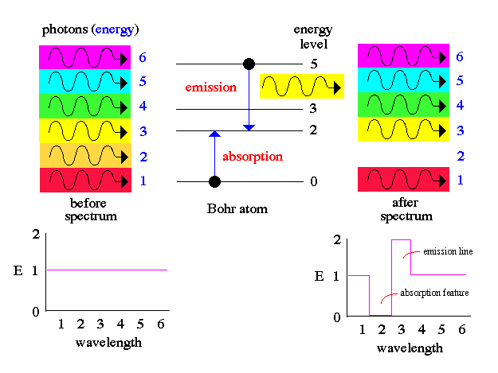

Web sites:

http://csep10.phys.utk.edu/astr162/lect/light/bohr.html

http://www.colorado.edu/physics/2000/quantumzone/bohr.html

http://www.upscale.utoronto.ca/GeneralInterest/Harrison/BohrModel/BohrModel.html

http://dbhs.wvusd.k12.ca.us/Electrons/Bohr-Model-part1.html

Bohr model and spectra for H:
http://wine1.sb.fsu.edu/chm1045/notes/Struct/Bohr/Struct03.htm

De Broglie wavelength
http://www.colorado.edu/physics/2000/quantumzone/debroglie_algebra.html

Development of atomic models:
http://www.epa.gov/radiation/understand/rutherford.htm

Bohr applet:
http://www.walter-fendt.de/ph11e/bohrh.htm

CWESTIYNAU.

- Beth oedd y ddau syniad newydd a gynigwyd gan Bohr?

- Pam y dylai electronau golli egni yn ôl yr hen syniadau?

- Beth yw ystyr y gair ‘cwanta’ o egni?

- Beth sy’n digwydd pan fo electron yn:

neidio i fyny i lefel uwch
neidio i lawr i lefel is

- Beth yw gwendid theori Bohr?

(f) Beth yw’r ddau fath o sbectrwm a geir a beth yw’r gwahaniaeth rhyngddynt?

